**Experiment 3.2 Paul Thomas 30 S3 CSB**

**Program**

| import java.util.*;  class DemoStringTokenizer{  public static void main(String[]args){  int n;  int sum=0;  Scanner sc = new Scanner(System.in);  System.out.println("Enter integers with one space");  String s = sc.nextLine();  StringTokenizer st = new StringTokenizer(s , " ");    while(st.hasMoreTokens()){  String temp = st.nextToken();  n = Integer.parseInt(temp);  System.out.println(n);  sum = sum +n ;  }    System.out.println("Sum of Integer is " + sum);  sc.close();  }  } |
| --- |

Program

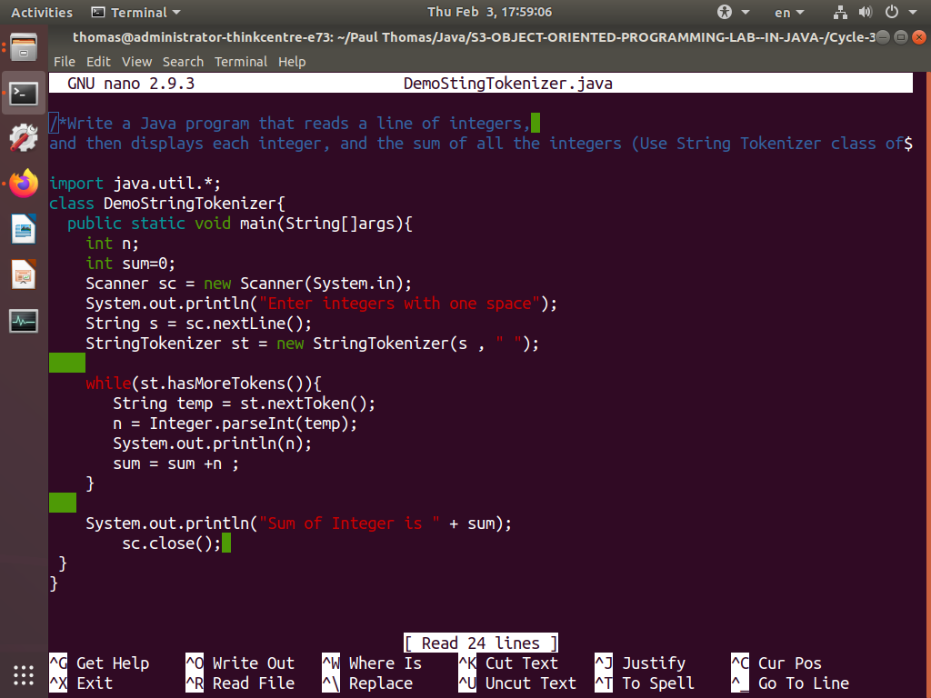

Output

